E4.
create or replace procedure marire_salarii_manager
(
p_manager_id in number
)
is
nr number;
begin
select count(*)
into nr
from employees
where manager_id = p_manager_id;

if nr = 0 then
dbms_output.put_line('Nu exista manager cu id-ul specificat: '||p_manager_id);
return;
end if;

update employees
set salary = salary * 1.10
where manager_id = p_manager_id or employee_id in (select employee_id from employees where manager_id = p_manager_id);
end;
/
begin
marire_salarii_manager(108);
marire_salarii_manager(114);
end;
/
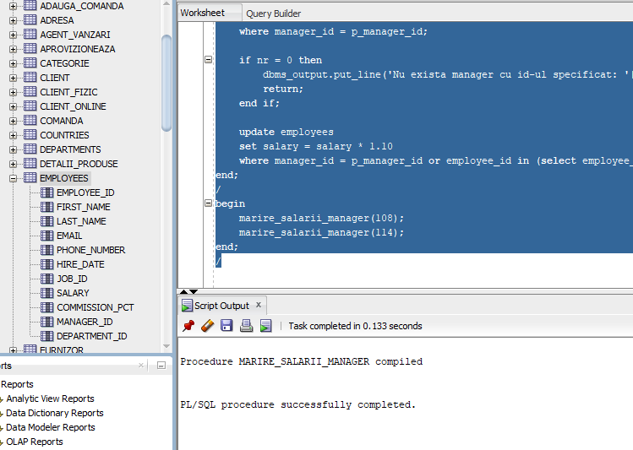
Inainte:
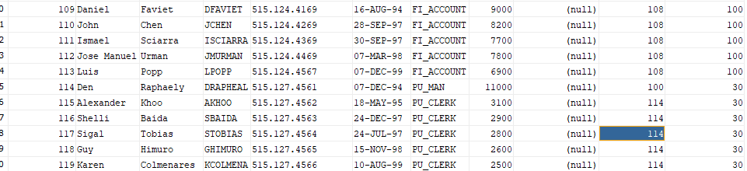
Dupa:
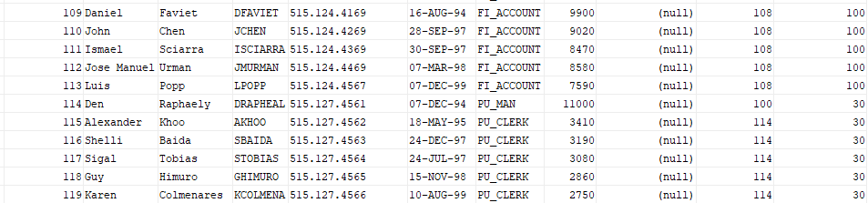
E6.
create or replace procedure info_angajare is
cursor c_dept is
select department_id, department_name
from departments;

cursor c_angajari (p_department_id number) is
select to_char(hire_date, 'day') as hire_day,
e.last_name,
e.hire_date,
e.salary
from employees e
where e.department_id = p_department_id
order by e.hire_date;

v_department_id departments.department_id%type;
v_department_name departments.department_name%type;
v_hire_day varchar2(10);
v_last_name employees.last_name%type;
v_hire_date employees.hire_date%type;
v_salary employees.salary%type;

type employee_rec is record (
last_name employees.last_name%type,
hire_date employees.hire_date%type,
salary employees.salary%type,
rank_position number
);
type table_emp is table of employee_rec index by binary_integer;
t_emp table_emp;

begin
for dept in c_dept loop-- cursor ciclu
v_department_id := dept.department_id;
v_department_name := dept.department_name;
dbms_output.put_line('Departamentul: ' || v_department_name);

open c_angajari(v_department_id);
loop
fetch c_angajari into v_hire_day, v_last_name, v_hire_date, v_salary;
exit when c_angajari%notfound;

t_emp(t_emp.count + 1) := employee_rec(v_last_name, v_hire_date, v_salary, null);
end loop;
close c_angajari;

if t_emp.count = 0
then
dbms_output.put_line('Nu sunt angajaii in departament');
continue;-- se continua cu urm dept
end if;

declare
v_prev_hire_date date := null;
v_rank number := 0;
begin
for i in 1..t_emp.count loop
if i = 1 or t_emp(i).hire_date != t_emp(i-1).hire_date
then
v_rank := i;-- rang curent
else
v_rank := t_emp(i-1).rank_position;-- daca se intampla sa aiba aceeasi vechime, pastrez rangul de la ang anterior
end if;

t_emp(i).rank_position := v_rank;-- rang nou
dbms_output.put_line('Pozitia '||t_emp(i).rank_position||': '||t_emp(i).last_name||' (data angajare: '||to_char(t_emp(i).hire_date, 'dd-mon-yyyy')||', salariu: '||t_emp(i).salary||')');
end loop;
end;

t_emp.delete;-- resetez lista pt urm departament
end loop;
end;
/
begin
info_angajare;
end;
/
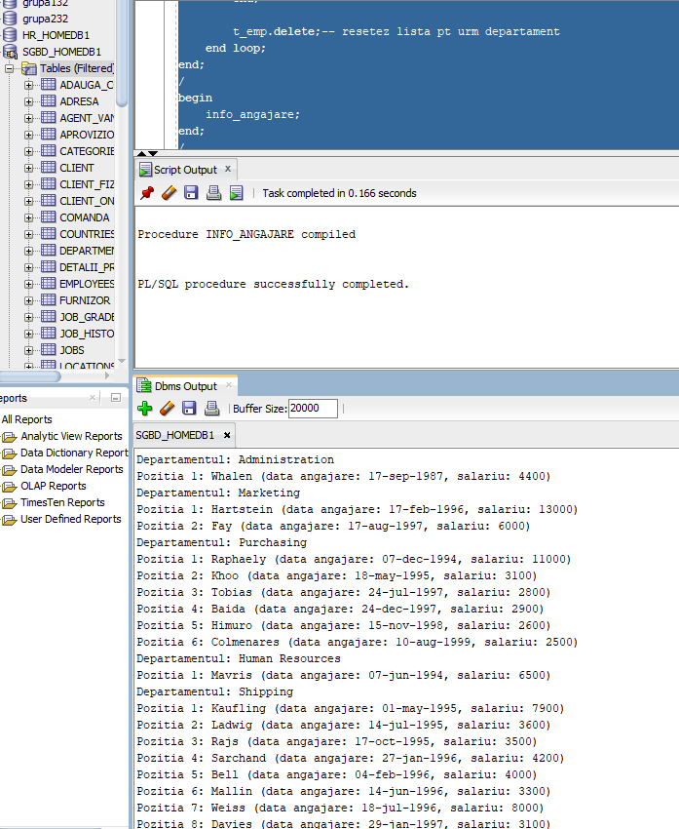
Departamentul: Administration
Pozitia 1: Whalen (data angajare: 17-sep-1987, salariu: 4400)
Departamentul: Marketing
Pozitia 1: Hartstein (data angajare: 17-feb-1996, salariu: 13000)
Pozitia 2: Fay (data angajare: 17-aug-1997, salariu: 6000)
Departamentul: Purchasing
Pozitia 1: Raphaely (data angajare: 07-dec-1994, salariu: 11000)
Pozitia 2: Khoo (data angajare: 18-may-1995, salariu: 3100)
Pozitia 3: Tobias (data angajare: 24-jul-1997, salariu: 2800)
Pozitia 4: Baida (data angajare: 24-dec-1997, salariu: 2900)
Pozitia 5: Himuro (data angajare: 15-nov-1998, salariu: 2600)
Pozitia 6: Colmenares (data angajare: 10-aug-1999, salariu: 2500)
Departamentul: Human Resources
Pozitia 1: Mavris (data angajare: 07-jun-1994, salariu: 6500)
Departamentul: Shipping
Pozitia 1: Kaufling (data angajare: 01-may-1995, salariu: 7900)
Pozitia 2: Ladwig (data angajare: 14-jul-1995, salariu: 3600)
Pozitia 3: Rajs (data angajare: 17-oct-1995, salariu: 3500)
Pozitia 4: Sarchand (data angajare: 27-jan-1996, salariu: 4200)
Pozitia 5: Bell (data angajare: 04-feb-1996, salariu: 4000)
Pozitia 6: Mallin (data angajare: 14-jun-1996, salariu: 3300)
Pozitia 7: Weiss (data angajare: 18-jul-1996, salariu: 8000)
Pozitia 8: Davies (data angajare: 29-jan-1997, salariu: 3100)
Pozitia 9: Marlow (data angajare: 16-feb-1997, salariu: 2500)
Pozitia 10: Bull (data angajare: 20-feb-1997, salariu: 4100)
Pozitia 11: Everett (data angajare: 03-mar-1997, salariu: 3900)
Pozitia 12: Fripp (data angajare: 10-apr-1997, salariu: 8200)
Pozitia 13: Chung (data angajare: 14-jun-1997, salariu: 3800)
Pozitia 14: Nayer (data angajare: 16-jul-1997, salariu: 3200)
Pozitia 15: Dilly (data angajare: 13-aug-1997, salariu: 3600)
Pozitia 16: Bissot (data angajare: 20-aug-1997, salariu: 3300)
Pozitia 17: Vollman (data angajare: 10-oct-1997, salariu: 6500)
Pozitia 18: Stiles (data angajare: 26-oct-1997, salariu: 3200)
Pozitia 19: Atkinson (data angajare: 30-oct-1997, salariu: 2800)
Pozitia 20: Taylor (data angajare: 24-jan-1998, salariu: 3200)
Pozitia 21: Seo (data angajare: 12-feb-1998, salariu: 2700)
Pozitia 22: Fleaur (data angajare: 23-feb-1998, salariu: 3100)
Pozitia 23: Matos (data angajare: 15-mar-1998, salariu: 2600)
Pozitia 24: Patel (data angajare: 06-apr-1998, salariu: 2500)
Pozitia 25: Walsh (data angajare: 24-apr-1998, salariu: 3100)
Pozitia 26: Feeney (data angajare: 23-may-1998, salariu: 3000)
Pozitia 27: Dellinger (data angajare: 24-jun-1998, salariu: 3400)
Pozitia 28: McCain (data angajare: 01-jul-1998, salariu: 3200)
Pozitia 29: Vargas (data angajare: 09-jul-1998, salariu: 2500)
Pozitia 30: Gates (data angajare: 11-jul-1998, salariu: 2900)
Pozitia 31: Rogers (data angajare: 26-aug-1998, salariu: 2900)
Pozitia 32: Mikkilineni (data angajare: 28-sep-1998, salariu: 2700)
Pozitia 33: Landry (data angajare: 14-jan-1999, salariu: 2400)
Pozitia 34: Cabrio (data angajare: 07-feb-1999, salariu: 3000)
Pozitia 35: Jones (data angajare: 17-mar-1999, salariu: 2800)
Pozitia 36: Olson (data angajare: 10-apr-1999, salariu: 2100)
Pozitia 37: Sullivan (data angajare: 21-jun-1999, salariu: 2500)
Pozitia 37: OConnell (data angajare: 21-jun-1999, salariu: 2600)
Pozitia 39: Mourgos (data angajare: 16-nov-1999, salariu: 5800)
Pozitia 40: Gee (data angajare: 12-dec-1999, salariu: 2400)
Pozitia 41: Perkins (data angajare: 19-dec-1999, salariu: 2500)
Pozitia 42: Grant (data angajare: 13-jan-2000, salariu: 2600)
Pozitia 43: Geoni (data angajare: 03-feb-2000, salariu: 2800)
Pozitia 44: Philtanker (data angajare: 06-feb-2000, salariu: 2200)
Pozitia 45: Markle (data angajare: 08-mar-2000, salariu: 2200)
Departamentul: IT
Pozitia 1: Hunold (data angajare: 03-jan-1990, salariu: 9000)
Pozitia 2: Ernst (data angajare: 21-may-1991, salariu: 6000)
Pozitia 3: Austin (data angajare: 25-jun-1997, salariu: 4800)
Pozitia 4: Pataballa (data angajare: 05-feb-1998, salariu: 4800)
Pozitia 5: Lorentz (data angajare: 07-feb-1999, salariu: 4200)
Departamentul: Public Relations
Pozitia 1: Baer (data angajare: 07-jun-1994, salariu: 10000)
Departamentul: Sales
Pozitia 1: King (data angajare: 30-jan-1996, salariu: 10000)
Pozitia 2: Sully (data angajare: 04-mar-1996, salariu: 9500)
Pozitia 3: Abel (data angajare: 11-may-1996, salariu: 11000)
Pozitia 4: McEwen (data angajare: 01-aug-1996, salariu: 9000)
Pozitia 5: Russell (data angajare: 01-oct-1996, salariu: 14000)
Pozitia 6: Partners (data angajare: 05-jan-1997, salariu: 13500)
Pozitia 7: Tucker (data angajare: 30-jan-1997, salariu: 10000)
Pozitia 8: Errazuriz (data angajare: 10-mar-1997, salariu: 12000)
Pozitia 8: Smith (data angajare: 10-mar-1997, salariu: 8000)
Pozitia 10: Ozer (data angajare: 11-mar-1997, salariu: 11500)
Pozitia 11: Hutton (data angajare: 19-mar-1997, salariu: 8800)
Pozitia 12: Bernstein (data angajare: 24-mar-1997, salariu: 9500)
Pozitia 13: Hall (data angajare: 20-aug-1997, salariu: 9000)
Pozitia 14: Vishney (data angajare: 11-nov-1997, salariu: 10500)
Pozitia 15: Doran (data angajare: 15-dec-1997, salariu: 7500)
Pozitia 16: Fox (data angajare: 24-jan-1998, salariu: 9600)
Pozitia 17: Bloom (data angajare: 23-mar-1998, salariu: 10000)
Pozitia 18: Taylor (data angajare: 24-mar-1998, salariu: 8600)
Pozitia 19: Olsen (data angajare: 30-mar-1998, salariu: 8000)
Pozitia 20: Livingston (data angajare: 23-apr-1998, salariu: 8400)
Pozitia 21: Sewall (data angajare: 03-nov-1998, salariu: 7000)
Pozitia 22: Cambrault (data angajare: 09-dec-1998, salariu: 7500)
Pozitia 23: Smith (data angajare: 23-feb-1999, salariu: 7400)
Pozitia 24: Greene (data angajare: 19-mar-1999, salariu: 9500)
Pozitia 25: Bates (data angajare: 24-mar-1999, salariu: 7300)
Pozitia 26: Cambrault (data angajare: 15-oct-1999, salariu: 11000)
Pozitia 27: Tuvault (data angajare: 23-nov-1999, salariu: 7000)
Pozitia 28: Johnson (data angajare: 04-jan-2000, salariu: 6200)
Pozitia 29: Marvins (data angajare: 24-jan-2000, salariu: 7200)
Pozitia 30: Zlotkey (data angajare: 29-jan-2000, salariu: 10500)
Pozitia 31: Lee (data angajare: 23-feb-2000, salariu: 6800)
Pozitia 32: Ande (data angajare: 24-mar-2000, salariu: 6400)
Pozitia 33: Banda (data angajare: 21-apr-2000, salariu: 6200)
Pozitia 33: Kumar (data angajare: 21-apr-2000, salariu: 6100)
Departamentul: Executive
Pozitia 1: King (data angajare: 17-jun-1987, salariu: 24000)
Pozitia 2: Kochhar (data angajare: 21-sep-1989, salariu: 17000)
Pozitia 3: De Haan (data angajare: 13-jan-1993, salariu: 17000)
Departamentul: Finance
Pozitia 1: Faviet (data angajare: 16-aug-1994, salariu: 9000)
Pozitia 2: Greenberg (data angajare: 17-aug-1994, salariu: 12000)
Pozitia 3: Chen (data angajare: 28-sep-1997, salariu: 8200)
Pozitia 4: Sciarra (data angajare: 30-sep-1997, salariu: 7700)
Pozitia 5: Urman (data angajare: 07-mar-1998, salariu: 7800)
Pozitia 6: Popp (data angajare: 07-dec-1999, salariu: 6900)
Departamentul: Accounting
Pozitia 1: Gietz (data angajare: 07-jun-1994, salariu: 8300)
Pozitia 1: Higgins (data angajare: 07-jun-1994, salariu: 12000)
Departamentul: Treasury
Nu sunt angajaii in departament
Departamentul: Corporate Tax
Nu sunt angajaii in departament
Departamentul: Control And Credit
Nu sunt angajaii in departament
Departamentul: Shareholder Services
Nu sunt angajaii in departament
Departamentul: Benefits
Nu sunt angajaii in departament
Departamentul: Manufacturing
Nu sunt angajaii in departament
Departamentul: Construction
Nu sunt angajaii in departament
Departamentul: Contracting
Nu sunt angajaii in departament
Departamentul: Operations
Nu sunt angajaii in departament
Departamentul: IT Support
Nu sunt angajaii in departament
Departamentul: NOC
Nu sunt angajaii in departament
Departamentul: IT Helpdesk
Nu sunt angajaii in departament
Departamentul: Government Sales
Nu sunt angajaii in departament
Departamentul: Retail Sales
Nu sunt angajaii in departament
Departamentul: Recruiting
Nu sunt angajaii in departament
Departamentul: Payroll
Nu sunt angajaii in departament

E7.
create or replace function obt_pret
(
v_nume piesa_mobilier.nume%type default 'DJUNGELSKOG'
)
return number is
v_pret piesa_mobilier.pret%type;
begin
select pret
into v_pret
from piesa_mobilier
where nume = v_nume;

return v_pret;
exception
when no_data_found then
raise_application_error(-20000, 'Nu exista piese de mobilier cu numele dat');
when too_many_rows then
raise_application_error(-20001, 'Exista mai multe piese de mobilier cu numele dat');
when others then
raise_application_error(-20002, 'Alta eroare');
end;
/
begin
dbms_output.put_line('Pretul e '||obt_pret);
end;
/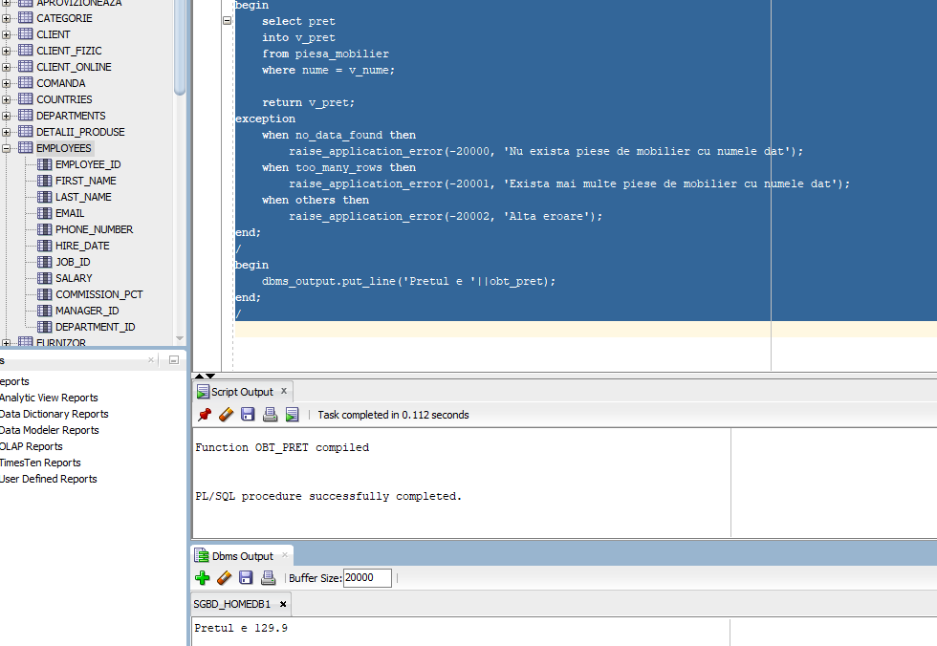
create or replace procedure obt_pret_proc
(
v_nume piesa_mobilier.nume%type default 'DJUNGELSKOG'
)
is
v_pret piesa_mobilier.pret%type;
begin
select pret into v_pret
from piesa_mobilier
where nume = v_nume;

dbms_output.put_line('Pretul piesei '||v_nume||' este: '||v_pret);
exception
when no_data_found then
raise_application_error(-20000, 'Nu exista piese de mobilier cu numele dat');
when too_many_rows then
raise_application_error(-20001, 'Exista mai multe piese de mobilier cu numele dat');
when others then
raise_application_error(-20002, 'Alta eroare');
end;
/
begin
obt_pret_proc();
end;
/
